Advanced WWW Authoring HTML and CSS

Top of Form

◄ Previous activity

Bottom of Form

Top of Form



Bottom of Form

Top of Form

Next activity ►

Bottom of Form

* [Home](http://www.webmastercert.com/moodle)
* [Courses](http://www.webmastercert.com/moodle/course/index.php)
* [Calendar](http://www.webmastercert.com/moodle/calendar/view.php?view=month)

You are here

* [**AWS**](http://www.webmastercert.com/moodle/)
* / **►**[**ITNW-1072**](http://www.webmastercert.com/moodle/course/view.php?id=39)
* / **► Online JSON Viewers**

While working with JSON, often you may need a JSON viewer. This document discusses several online JSON viewer. Hopefully, this will help you to select one depending upon your requirement.

**jsonviewer.stack.hu**

This may be the most widely used online JSON viewer. Indeed it is feature rich to be used widely.



You can directly copy your JSON text in this online viewer. Or you may use the load JOSN data button to supply an url and the viewer will load JSON form that resource. After the JSON code is visible in the viewer, you can click on Format to format the code.

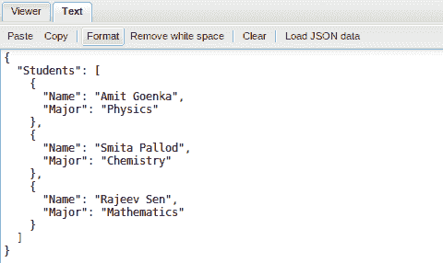

Clicking on Viewer then will change the mode of the viewer and you can expand or collapse the JSON tree on the left hand side pane to view the name and values on the right hand side pane.

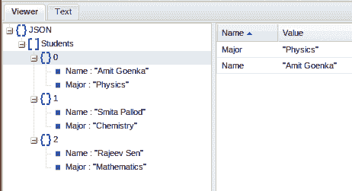

In the Text mode, you can minify the JSON code by clicking on the Remove white space.



And finally, you can clear the code by clicking on Clear.

**jsoneditoronline.org**

jsoneditoronline.org is another excellent JOSN viewer. It comes with a default JSON code which you may clear by clicking on clear button.You may load your own JSON code by clicking on Open and then you choose to open from a local file (Open file) and form a url (Open url).

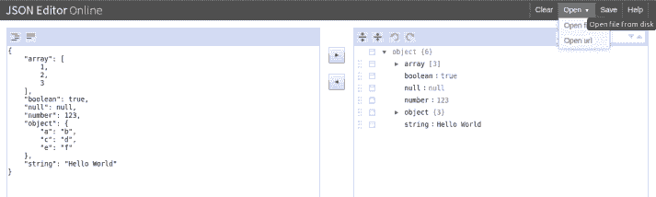

You click on JSON to editor and you can see the code you loaded as a JSON tree on the right hand side pane.

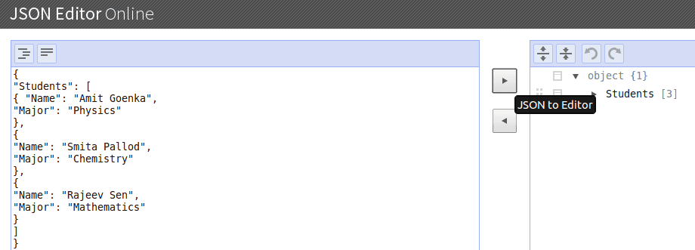

You can then expand and collapse the tree to view various components of the JSON tree.

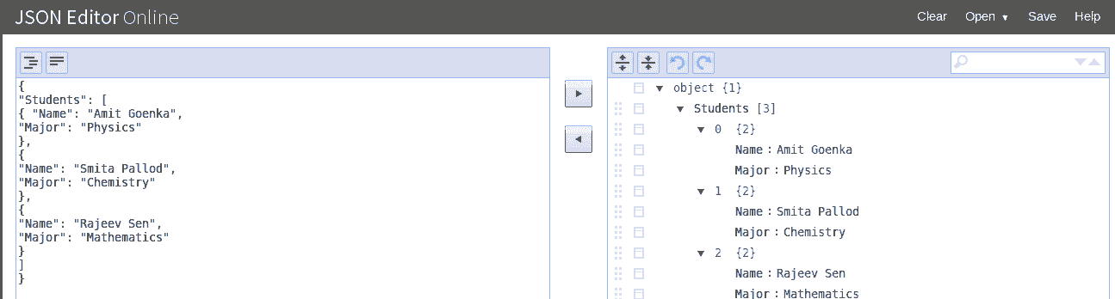

There is search box on the editor, which you may use to search various components of the JSON code.

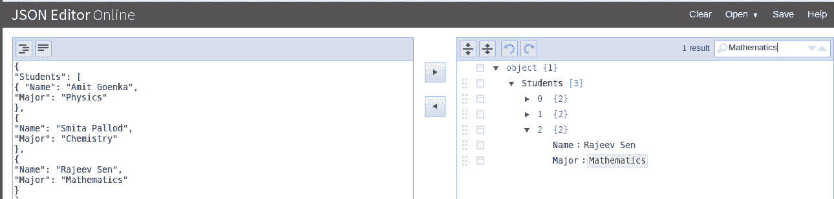

Once you click on the Save button, the document in question is saved on your local machine (within default download location).

On the left hand pane, the left most button is to format your JSON code.

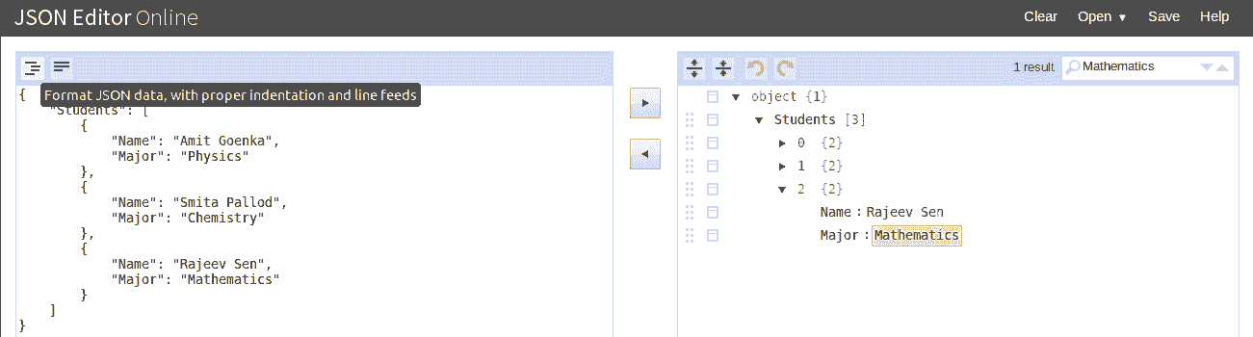

And the button net to that is to remove all the white spaces and make it compact.

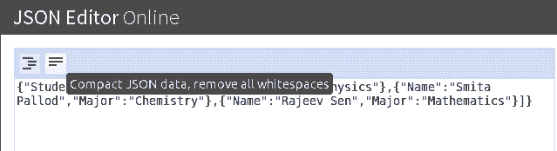

**Online JSON Tree Viewer Tool**

This is tool is located at http://www.jquery4u.com/demos/online-json-tree-viewer/. You can either click on Choose a file and upload a JSOn file or you may click on Copy and Paste and simply copy JSON code from a source.

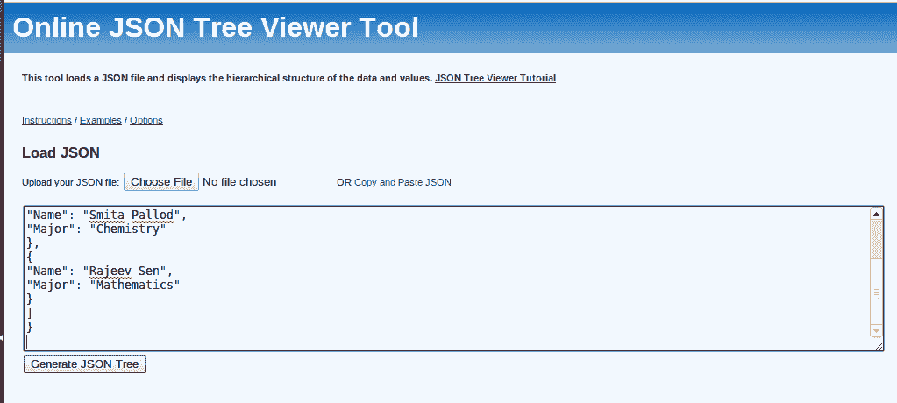

Once the code is there, click on the Generate JSON tree to obtain a tree view of the JSON code.

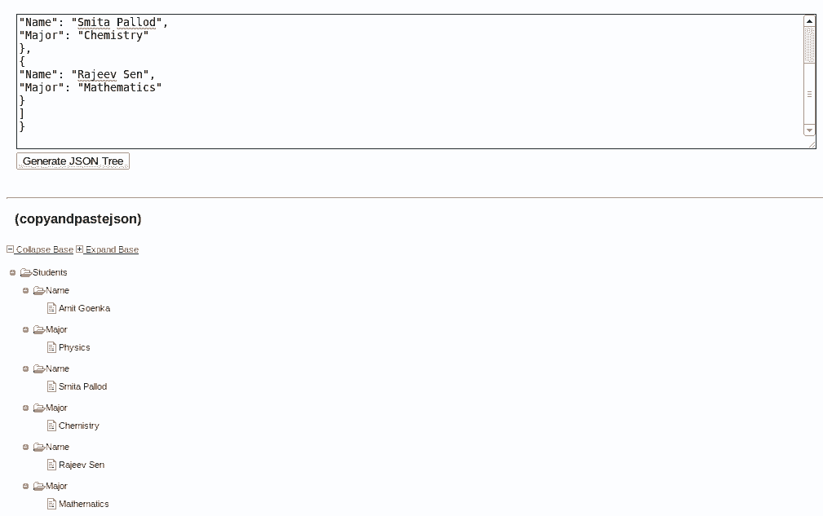

You can now Collapse and Expand the JSON tree. Another good feature of this tool is, when you select a component of the JSON tree, you can see a popup on the browser showing you the path of the JSON object selected.

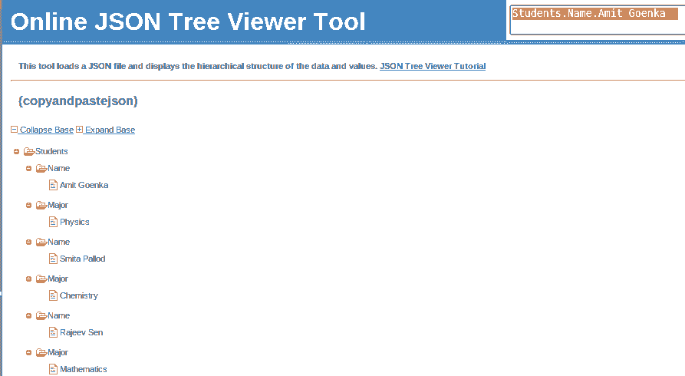

You can not save, clear or remove white space using this tool though.

**JSON Visualization**

This is feature rich online JSON viewer, available at http://chris.photobooks.com/json/default.htm. You can paste the JSON code under Input. You may also click Load and load a JSON file from remote.

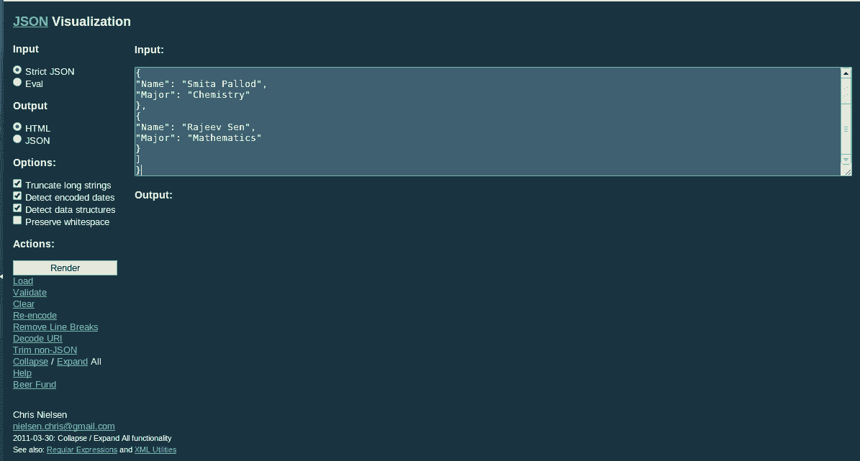

Click on render to generate either JSON or HTML, depending upon the selection you have made under radio boxes of Output.

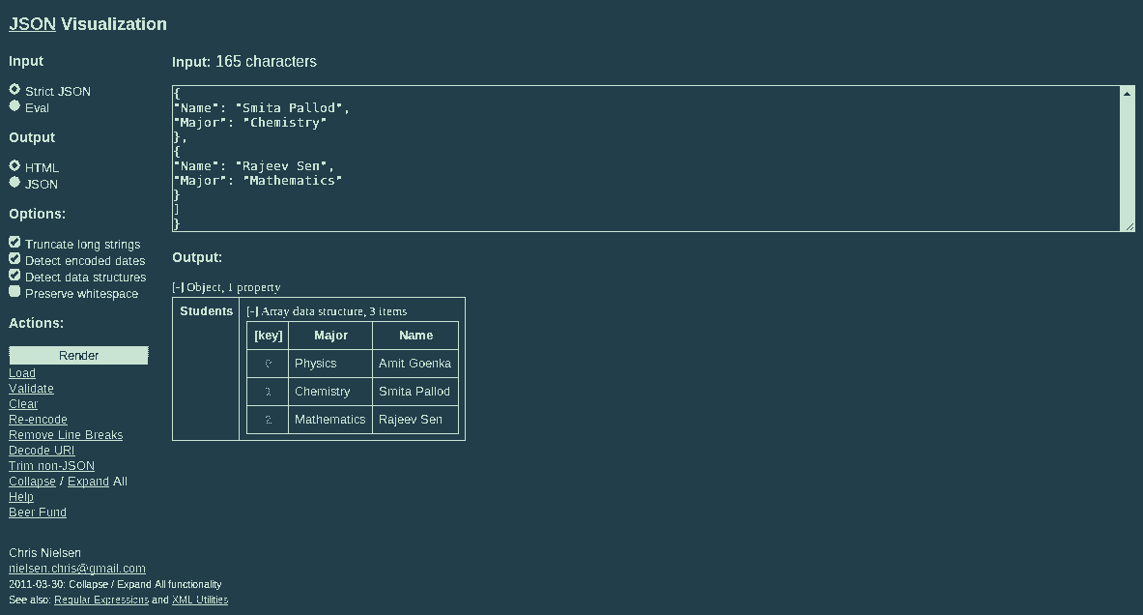

By clicking on Expand/Collapse you can expand and collapse the JSON tree rendered. You can click on any of the JSON component and it shows it's location in the JSON tree.

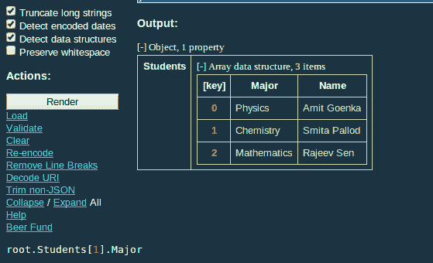

Clicking on validate will validate your JSON code.

Clicking on reencode will reencode the JSON code.

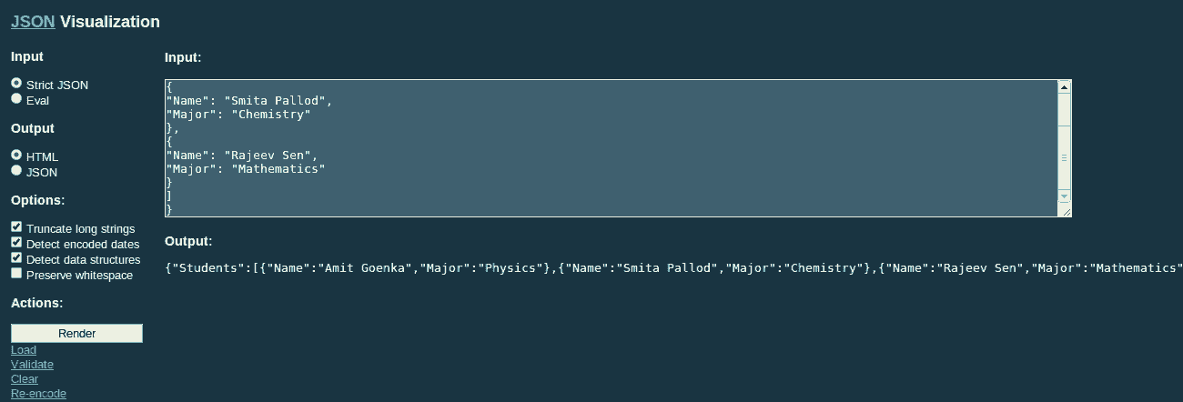

**Json viewer**

This tool is available at http://www.jsonviewer.com/. Like other tools, this also allows you to load JSON from either url or you can directly paste the code. Though the loading from url is available on IE only. After you click on Parse JSON data, Json Object view is rendered.

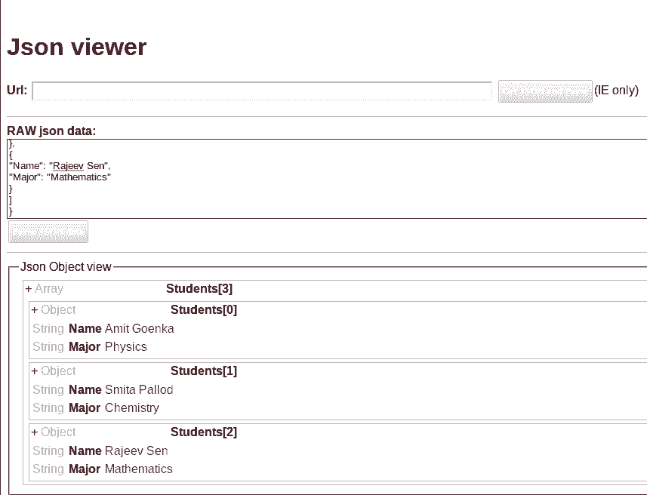

**JSON Parser Online**

You can access this tool at http://json.parser.online.fr/. Once you paste code on the left hand side panel, you can view JSON tree w.r.t string parsing and eval.

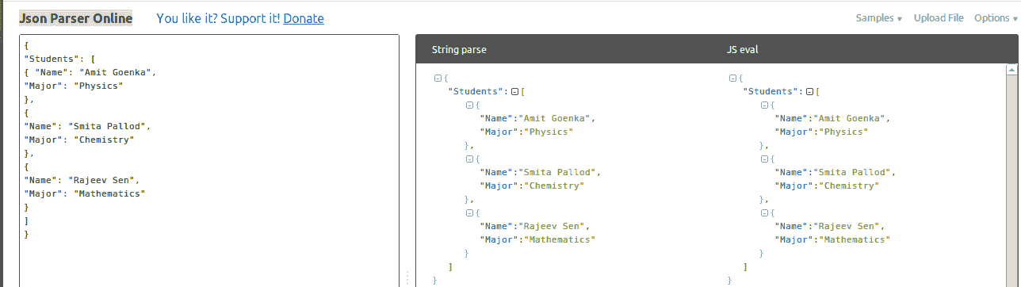

Clicking on the Options opens a menu and you can choose various options from there.

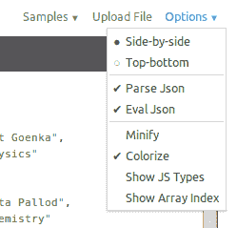

This tool has several JSON samples including one Invalid JSON sample which is great, particularly for beginners.

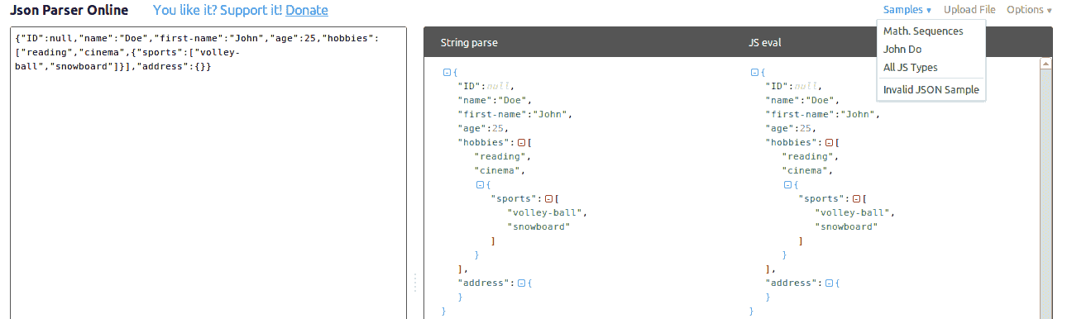

**Free Online JSON Parser**

http://jsonparser.com/ offers this tool. You can copy code, format, view JSON tree and collapse and expand the tree with this tool.

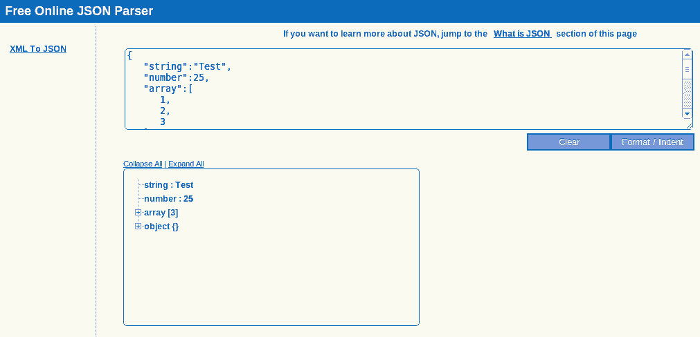

**JSONView in Chrome**

This browser extension for Chrome is an excellent tool. You can obtain it from https://chrome.google.com/webstore/detail/jsonview/chklaanhfefbnpoihckbnefhakgolnmc?hl=en. You can use the context menu to copy the JSON path or the value.

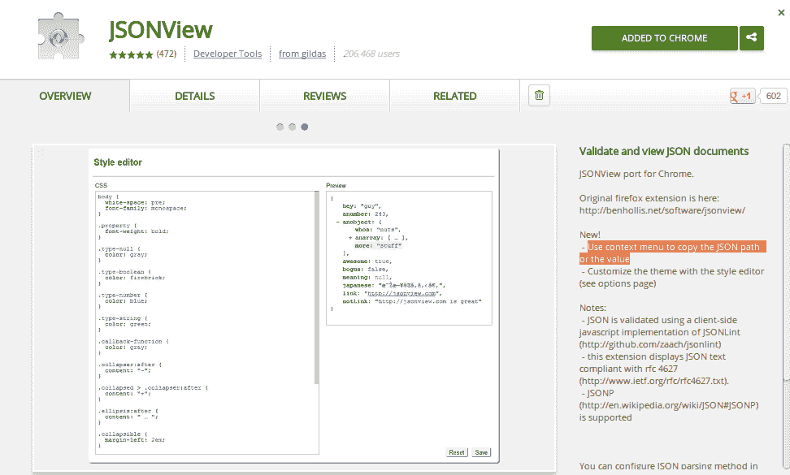

There is an extension for Firefox also. You can obtain it from here:https://addons.mozilla.org/EN-us/firefox/addon/jsonview/.

Last modified: Wednesday, 29 July 2015, 11:45 AM

You are logged in as [edris safari](http://www.webmastercert.com/moodle/user/view.php?id=4668&course=39) ([Logout](http://www.webmastercert.com/moodle/login/logout.php?sesskey=OLBhUtyV0P))

[ITNW-1072](http://www.webmastercert.com/moodle/course/view.php?id=39)

Advanced WWW Authoring HTML and CSS

Top of Form

◄ Previous activity

Bottom of Form

Top of Form



Bottom of Form

Top of Form

Next activity ►

Bottom of Form

* [Home](http://www.webmastercert.com/moodle)
* [Courses](http://www.webmastercert.com/moodle/course/index.php)
* [Calendar](http://www.webmastercert.com/moodle/calendar/view.php?view=month)

You are here

* [**AWS**](http://www.webmastercert.com/moodle/)
* / **►**[**ITNW-1072**](http://www.webmastercert.com/moodle/course/view.php?id=39)
* / **► JSON and Javascript**

**JavaScript JSON object**

The JavaScript JSON object comprises methods that convert JavaScript values to JSON format and JSON notation to JavaScript values.

JSON methods - JSON.stringify and JSON.parse

**JSON.stringify**

JSON.stringify is used to convert JavaScript values to JSON.

**JSON.stringify example**

**JSON.parse**

JSON.parse is used to convert JSON notation to JavaScript values.

**JSON.parse example**

**Live**

[View the Example of JavaScript JSON.parse online.](http://www.w3resource.com/JSON/JavaScript-JSON.parse-example.html)

**Why you should not use eval() with JSON**

It's not safe to parse JSON using eval for security reasons. Eval() allows passing Javascript code that could be dangerous to the site through exploits.

Last modified: Wednesday, 29 July 2015, 12:12 PM

You are logged in as [edris safari](http://www.webmastercert.com/moodle/user/view.php?id=4668&course=39) ([Logout](http://www.webmastercert.com/moodle/login/logout.php?sesskey=OLBhUtyV0P))

[ITNW-1072](http://www.webmastercert.com/moodle/course/view.php?id=39)

Advanced WWW Authoring HTML and CSS

Top of Form

◄ Previous activity

Bottom of Form

Top of Form



Bottom of Form

Top of Form

Next activity ►

Bottom of Form

* [Home](http://www.webmastercert.com/moodle)
* [Courses](http://www.webmastercert.com/moodle/course/index.php)
* [Calendar](http://www.webmastercert.com/moodle/calendar/view.php?view=month)

You are here

* [**AWS**](http://www.webmastercert.com/moodle/)
* / **►**[**ITNW-1072**](http://www.webmastercert.com/moodle/course/view.php?id=39)
* / **► JSONP**

JSONP, is JSON with padding. JSONP is used to request data from a server residing in a different domain.

**Same Origin Policy**

In general, this policy states that, if avprotocol (like http), port number (like 80) and host (like example.com) is different from where data is being requested, it should not be permitted.

But the HTML <script> element is allowed to perform content retrieval from foreign origins.

**How JSONP works - Step by Step**

Step 1 - You need to create a callback function. The function accepts some data. Like following code :

function w3r_callback(data){  
console.log(data);  
}

Step 2 - Include a script in your web page which contains the callback function created in step 1, as a parameter.

<script src="http://www.example.com?q=w3r_callback"><script>

Step 3 - It outputs a script which calls the function and the requested data is passed.

w3r_callback({  
"FirstName" : "xyz",  
"LastName" : "abc",  
"Grade" : "A"  
}  
);

Last modified: Tuesday, 28 July 2015, 09:26 AM

You are logged in as [edris safari](http://www.webmastercert.com/moodle/user/view.php?id=4668&course=39) ([Logout](http://www.webmastercert.com/moodle/login/logout.php?sesskey=OLBhUtyV0P))

[ITNW-1072](http://www.webmastercert.com/moodle/course/view.php?id=39)

Advanced WWW Authoring HTML and CSS

Top of Form

◄ Previous activity

Bottom of Form

Top of Form



Bottom of Form

Top of Form

Next activity ►

Bottom of Form

* [Home](http://www.webmastercert.com/moodle)
* [Courses](http://www.webmastercert.com/moodle/course/index.php)
* [Calendar](http://www.webmastercert.com/moodle/calendar/view.php?view=month)

You are here

* [**AWS**](http://www.webmastercert.com/moodle/)
* / **►**[**ITNW-1072**](http://www.webmastercert.com/moodle/course/view.php?id=39)
* / **► JSON vs. XML**

**JSON vs XML**

Since XML is also used as data interchange format, we will try to draw a comparison between them. The purpose of the comparison is not to determine which is better, rather we will try to understand which is more suitable for storing specific kinds of data.

* XML is more expressive than JSON. XML sometimes also suffers from using tags repeatedly, where as JSON is much more concise.
* XML is more complex than JSON.
* There are several specifications to define schema(metadata) for XML, for example DTD and XSD. JSON schema is there for doing the same for JSON, but it is not as widely used as XML schemas.
* XML can be used with most of the programming languages as JSON. But the point is, when you are working with XML, then you have you are actually trying match two systems those data structures are different. In case of JSON though, since objects and arrays are basic data structures used, it is easy to work with them in programs.
* For selecting specific parts of an XML document, there is standard specification called XPath. This is widely used. In JSON, we have JSONPath to do the same, but not widely in use.
* XML has Xquery specification for querying XML data. JSON though have JAQL, JSONiq etc, but they are not in use widely.
* XML has XSLT specification which may be used to apply style to an XML document. JSON does not have any such thing.

**Typical uses of JSON**

**Application Programming Interfaces**:

APIs are the most widely used area where JSON is used for data exchange. Specially, social Web applications have APIs, so that developers can consume the huge amount of data collected by the app and then can create derivative apps.

Twitter, Facebook, Linkedin, Flicker, Dribble, all the well known apps on internet today have an API and use JSON as their preferred format for serving data to the developers. Out of these APIs, some have support for both JSON and XML, but some support only JSON.

We will see a simple demonstration of the Rotten Tomatoes API, to get a feel of how JSON is used in APIs. In this demo, we are querying rottentomatoes.com for the name and thumbnail poster of the movie containing the string "Life is beautiful" using JavaScript and Jquery. It returns the result in JSON format and then it is displayed in the browser.

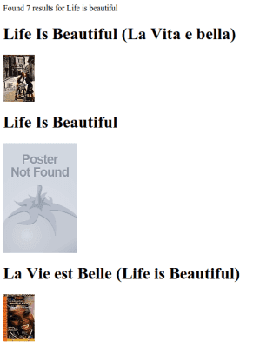

Last modified: Monday, 27 July 2015, 10:40 AM

You are logged in as [edris safari](http://www.webmastercert.com/moodle/user/view.php?id=4668&course=39) ([Logout](http://www.webmastercert.com/moodle/login/logout.php?sesskey=OLBhUtyV0P))

[ITNW-1072](http://www.webmastercert.com/moodle/course/view.php?id=39)